S01: Text to Audio
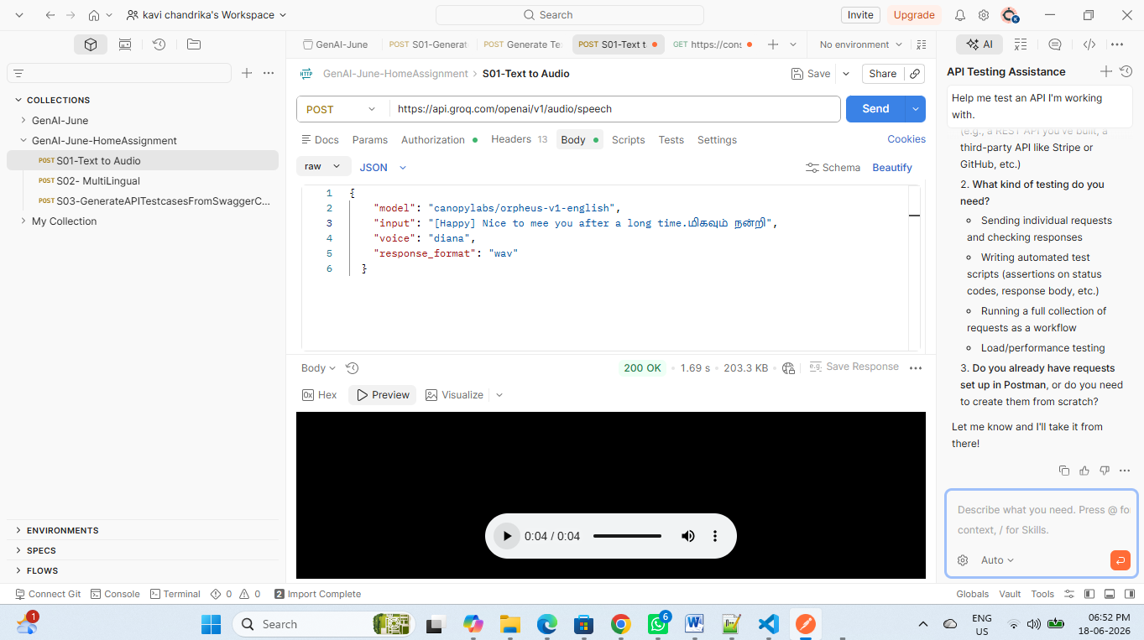
S02: MultiLingual
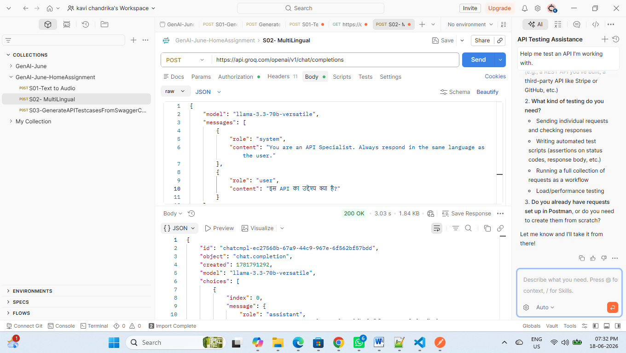
Response:
{
"id": "chatcmpl-ec27568b-67a9-44c9-967e-6f562bf57bdd",
"object": "chat.completion",
"created": 1781791292,
"model": "llama-3.3-70b-versatile",
"choices": [
{
"index": 0,
"message": {
"role": "assistant",
"content": "इस API का उद्देश्य उपयोगकर्ताओं को विभिन्न प्रकार की सेवाओं और संसाधनों तक पहुंचने की अनुमति देना है, जैसे कि डेटा प्राप्त करना, ऑपरेशन करना, और अन्य कार्यों को स्वचालित करना। API का मुख्य उद्देश्य उपयोगकर्ताओं को एक मानकीकृत और सुरक्षित तरीके से सेवाओं तक पहुंचने की अनुमति देना है, जिससे वे अपने अनुप्रयोगों और सिस्टम में एकीकरण कर सकें।\n\nयह API विभिन्न प्रकार के कार्यों को पूरा कर सकता है, जैसे कि:\n\n* डेटा प्राप्त करना और अद्यतन करना\n* ऑपरेशन करना और नियंत्रण करना\n* सेवाओं का प्रबंधन करना और उनकी निगरानी करना\n* सुरक्षा और पहुंच नियंत्रण को लागू करना\n\nइस API का उद्देश्य उपयोगकर्ताओं को अपने कार्यों को स्वचालित करने और अपने अनुप्रयोगों और सिस्टम को अधिक कुशल और प्रभावी बनाने में मदद करना है।"
},
"logprobs": null,
"finish_reason": "stop"
}
],
"usage": {
"queue_time": 1.5026812569999999,
"prompt_tokens": 64,
"prompt_time": 0.041857692,
"completion_tokens": 326,
"completion_time": 1.011538432,
"total_tokens": 390,
"total_time": 1.053396124
},
"usage_breakdown": null,
"system_fingerprint": "fp_0761e44d7b",
"x_groq": {
"id": "req_01kvdgjwe7fevb3jfpgx0cesgc",
"seed": 631968778
},
"service_tier": "on_demand"
}

S03: GenerateAPITestcasesfromSwaggerCode
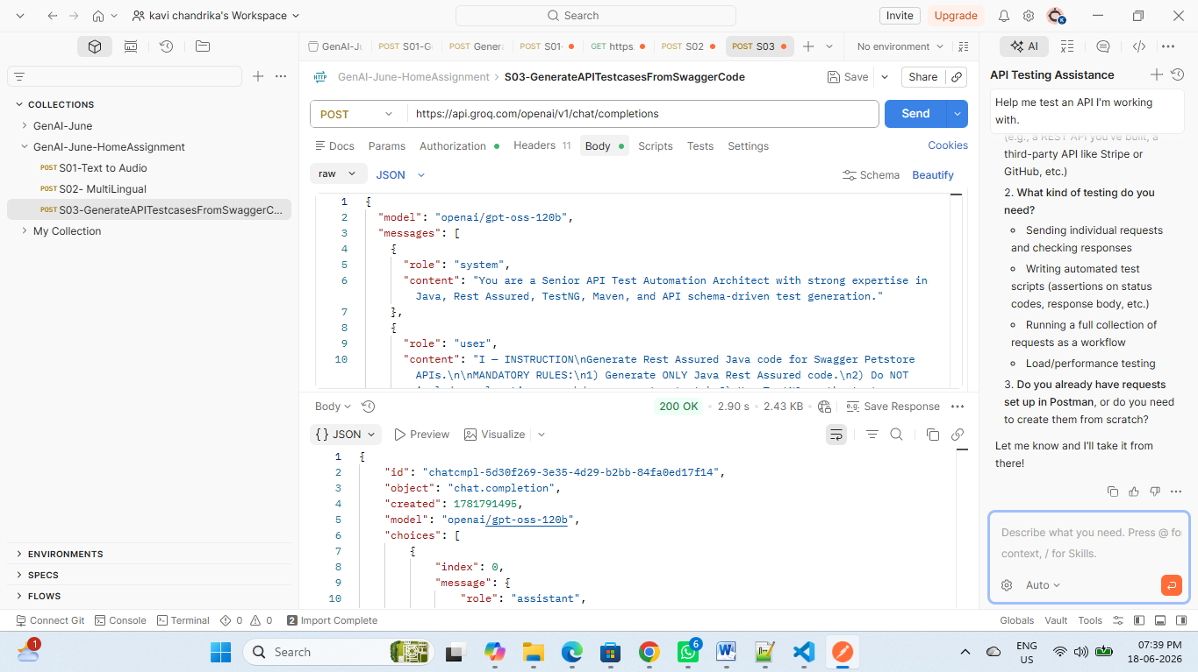
Response:
{
"id": "chatcmpl-5d30f269-3e35-4d29-b2bb-84fa0ed17f14",
"object": "chat.completion",
"created": 1781791495,
"model": "openai/gpt-oss-120b",
"choices": [
{
"index": 0,
"message": {
"role": "assistant",
"content": "import io.restassured.RestAssured;\nimport io.restassured.http.ContentType;\nimport io.restassured.response.Response;\nimport org.testng.Assert;\nimport org.testng.annotations.BeforeClass;\nimport org.testng.annotations.Test;\n\nimport java.util.HashMap;\nimport java.util.Map;\n\npublic class PetStoreCrudTest {\n\n private static final String BASE_URI = \"https://petstore.swagger.io/v2\";\n private static long petId;\n private static final String PET_NAME = \"Fluffy\";\n private static final String UPDATED_PET_NAME = \"FluffyUpdated\";\n\n @BeforeClass\n public void setUp() {\n RestAssured.baseURI = BASE_URI;\n }\n\n @Test\n public void createPet() {\n petId = System.currentTimeMillis();\n Map<String, Object> pet = new HashMap<>();\n pet.put(\"id\", petId);\n pet.put(\"name\", PET_NAME);\n pet.put(\"status\", \"available\");\n\n Response response = RestAssured.given()\n .contentType(ContentType.JSON)\n .body(pet)\n .post(\"/pet\")\n .then()\n .extract()\n .response();\n\n Assert.assertEquals(response.getStatusCode(), 200, \"Create pet status code\");\n Assert.assertEquals(response.jsonPath().getLong(\"id\"), petId, \"Pet ID\");\n Assert.assertEquals(response.jsonPath().getString(\"name\"), PET_NAME, \"Pet name\");\n Assert.assertEquals(response.jsonPath().getString(\"status\"), \"available\", \"Pet status\");\n }\n\n @Test(dependsOnMethods = \"createPet\")\n public void getPetById() {\n Response response = RestAssured.given()\n .accept(ContentType.JSON)\n .get(\"/pet/{petId}\", petId)\n .then()\n .extract()\n .response();\n\n Assert.assertEquals(response.getStatusCode(), 200, \"Get pet status code\");\n Assert.assertEquals(response.jsonPath().getLong(\"id\"), petId, \"Pet ID\");\n Assert.assertEquals(response.jsonPath().getString(\"name\"), PET_NAME, \"Pet name\");\n Assert.assertEquals(response.jsonPath().getString(\"status\"), \"available\", \"Pet status\");\n }\n\n @Test(dependsOnMethods = \"getPetById\")\n public void updatePet() {\n Map<String, Object> petUpdate = new HashMap<>();\n petUpdate.put(\"id\", petId);\n petUpdate.put(\"name\", UPDATED_PET_NAME);\n petUpdate.put(\"status\", \"pending\");\n\n Response response = RestAssured.given()\n .contentType(ContentType.JSON)\n .body(petUpdate)\n .put(\"/pet\")\n .then()\n .extract()\n .response();\n\n Assert.assertEquals(response.getStatusCode(), 200, \"Update pet status code\");\n Assert.assertEquals(response.jsonPath().getLong(\"id\"), petId, \"Pet ID\");\n Assert.assertEquals(response.jsonPath().getString(\"name\"), UPDATED_PET_NAME, \"Updated pet name\");\n Assert.assertEquals(response.jsonPath().getString(\"status\"), \"pending\", \"Updated pet status\");\n }\n\n @Test(dependsOnMethods = \"updatePet\")\n public void deletePet() {\n Response deleteResponse = RestAssured.given()\n .delete(\"/pet/{petId}\", petId)\n .then()\n .extract()\n .response();\n\n Assert.assertEquals(deleteResponse.getStatusCode(), 200, \"Delete pet status code\");\n\n Response getAfterDelete = RestAssured.given()\n .accept(ContentType.JSON)\n .get(\"/pet/{petId}\", petId)\n .then()\n .extract()\n .response();\n\n Assert.assertEquals(getAfterDelete.getStatusCode(), 404, \"Get after delete should return 404\");\n }\n}",
"reasoning": "We need to output Java code with imports, class, @BeforeClass, methods for CRUD. Use RestAssured, TestNG. Need reusable base URI setup. Use meaningful names, request bodies, assertions for status code and important fields. Use production style. No markdown, no explanations. Just code.\n\nWe should import static io.restassured.RestAssured.*; and other needed.\n\nUse BaseTest class maybe within same file? They said one test class, so can include static setup in same class.\n\nWe'll define BASE_URI = \"https://petstore.swagger.io/v2\". Use @BeforeClass to set RestAssured.baseURI.\n\nWe'll use a Pet model? Could just use Map or JSON string. Use JSONObject? Simpler: use a POJO class Pet inside same file? Might be too big. Use HashMap for request body.\n\nWe need to store petId across methods. Use static long petId.\n\nTest methods:\n\n- createPet: POST /pet with body containing id, name, status. Use random id (e.g., System.currentTimeMillis()). Save petId. Assert status 200, response id matches, name matches.\n\n- getPetById: GET /pet/{petId}. Assert status 200, id matches, name matches.\n\n- updatePet: PUT /pet with updated name/status. Assert status 200, name updated.\n\n- deletePet: DELETE /pet/{petId}. Assert status 200. Optionally verify get returns 404.\n\nTestNG order: use dependsOnMethods to ensure sequence.\n\nAdd assertions: use org.testng.Assert.\n\nNow produce code.\n\n"
},
"logprobs": null,
"finish_reason": "stop"
}
],
"usage": {
"queue_time": 0.291008343,
"prompt_tokens": 396,
"prompt_time": 0.086251707,
"completion_tokens": 1131,
"completion_time": 2.405212381,
"total_tokens": 1527,
"total_time": 2.491464088,
"completion_tokens_details": {
"reasoning_tokens": 326
}
},
"usage_breakdown": null,
"system_fingerprint": "fp_5082008e34",
"x_groq": {
"id": "req_01kvdgs2rme1p8vwsrs592614b",
"seed": 1072399768
},
"service_tier": "on_demand"
}

import io.restassured.RestAssured;
import io.restassured.http.ContentType;
import io.restassured.response.Response;
import org.testng.Assert;
import org.testng.annotations.BeforeClass;
import org.testng.annotations.Test;
import java.util.HashMap;
import java.util.Map;

public class PetStoreCrudTest {

private static final String BASE_URI = "https://petstore.swagger.io/v2";

private static final String INITIAL_PET_NAME = "Fluffy";
private static final String UPDATED_PET_NAME = "FluffyUpdated";

private static final String AVAILABLE_STATUS = "available";
private static final String PENDING_STATUS = "pending";

private long petId;

@BeforeClass
public void setup() {
RestAssured.baseURI = BASE_URI;
}

@Test(priority = 1)
public void createPet() {

petId = System.currentTimeMillis();

Map<String, Object> requestBody =
buildPetRequest(petId, INITIAL_PET_NAME, AVAILABLE_STATUS);

Response response =
RestAssured.given()
.contentType(ContentType.JSON)
.body(requestBody)
.when()
.post("/pet")
.then()
.extract()
.response();

Assert.assertEquals(response.getStatusCode(), 200);

Assert.assertEquals(
response.jsonPath().getLong("id"),
petId,
"Pet ID mismatch");

Assert.assertEquals(
response.jsonPath().getString("name"),
INITIAL_PET_NAME,
"Pet name mismatch");

Assert.assertEquals(
response.jsonPath().getString("status"),
AVAILABLE_STATUS,
"Pet status mismatch");
}

@Test(priority = 2, dependsOnMethods = "createPet")
public void getPetById() {

Response response =
RestAssured.given()
.accept(ContentType.JSON)
.pathParam("petId", petId)
.when()
.get("/pet/{petId}")
.then()
.extract()
.response();

Assert.assertEquals(response.getStatusCode(), 200);

Assert.assertEquals(
response.jsonPath().getLong("id"),
petId);

Assert.assertEquals(
response.jsonPath().getString("name"),
INITIAL_PET_NAME);

Assert.assertEquals(
response.jsonPath().getString("status"),
AVAILABLE_STATUS);
}

@Test(priority = 3, dependsOnMethods = "getPetById")
public void updatePet() {

Map<String, Object> requestBody =
buildPetRequest(petId, UPDATED_PET_NAME, PENDING_STATUS);

Response response =
RestAssured.given()
.contentType(ContentType.JSON)
.body(requestBody)
.when()
.put("/pet")
.then()
.extract()
.response();

Assert.assertEquals(response.getStatusCode(), 200);

Assert.assertEquals(
response.jsonPath().getLong("id"),
petId);

Assert.assertEquals(
response.jsonPath().getString("name"),
UPDATED_PET_NAME);

Assert.assertEquals(
response.jsonPath().getString("status"),
PENDING_STATUS);
}

@Test(priority = 4, dependsOnMethods = "updatePet")
public void deletePet() {

Response deleteResponse =
RestAssured.given()
.pathParam("petId", petId)
.when()
.delete("/pet/{petId}")
.then()
.extract()
.response();

Assert.assertEquals(
deleteResponse.getStatusCode(),
200,
"Delete operation failed");

Response getDeletedPetResponse =
RestAssured.given()
.accept(ContentType.JSON)
.pathParam("petId", petId)
.when()
.get("/pet/{petId}")
.then()
.extract()
.response();

Assert.assertEquals(
getDeletedPetResponse.getStatusCode(),
404,
"Deleted pet should not be found");
}

private Map<String, Object> buildPetRequest(
long petId,
String petName,
String status) {

Map<String, Object> pet = new HashMap<>();

pet.put("id", petId);
pet.put("name", petName);
pet.put("status", status);

return pet;
}
}

